Task No. 01: Write step to install visual studio.
STEPS:
- Search Virtual Studio on Internet and click on the Link as shown in picture:
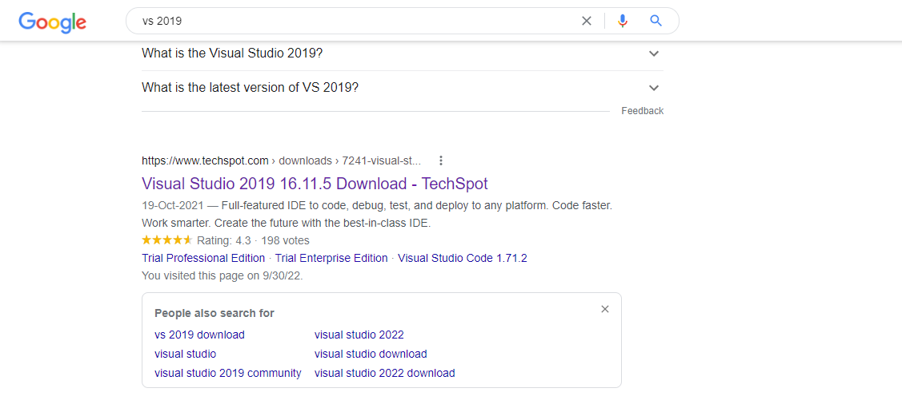
- Click on Free Community Edition and Downloading will start:
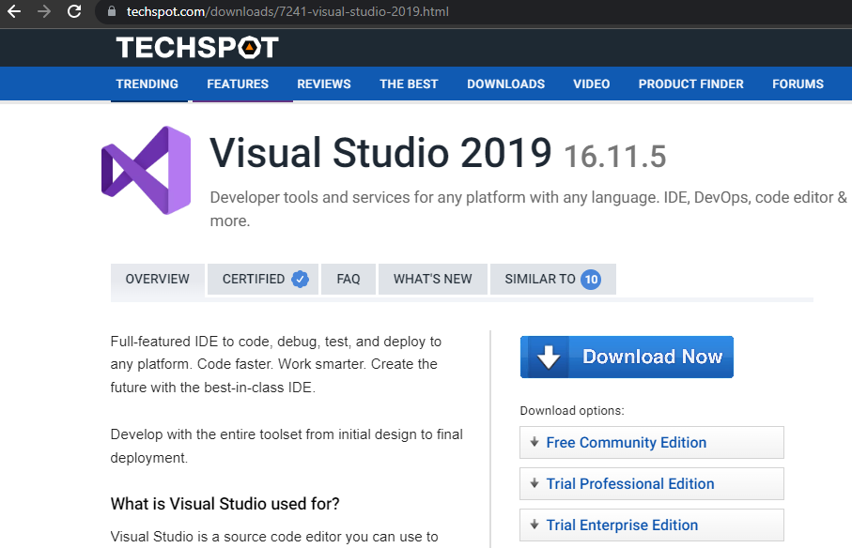

- Now open installation package and Download Visual Studio:
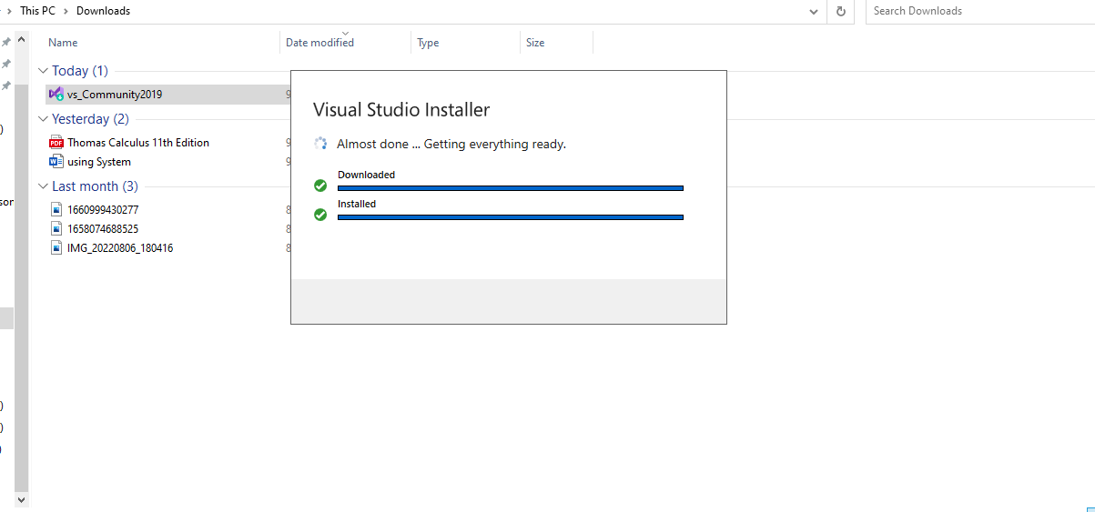
- Now open the visual studio installer and Download .NET desktop Development:
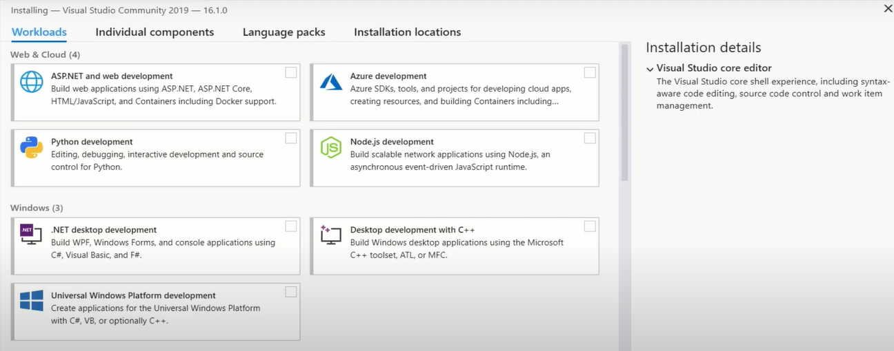
- Visual Studio Will start automatically once it is Downloaded